12.44: Using the mass of the sun for in Eq. (12.32) gives

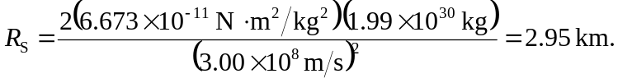

That is, Eq. (12.32) may be rewritten
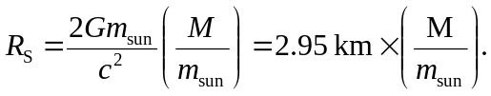

Using 3.0 km instead of 2.95 km is accurate to 1.7%.

